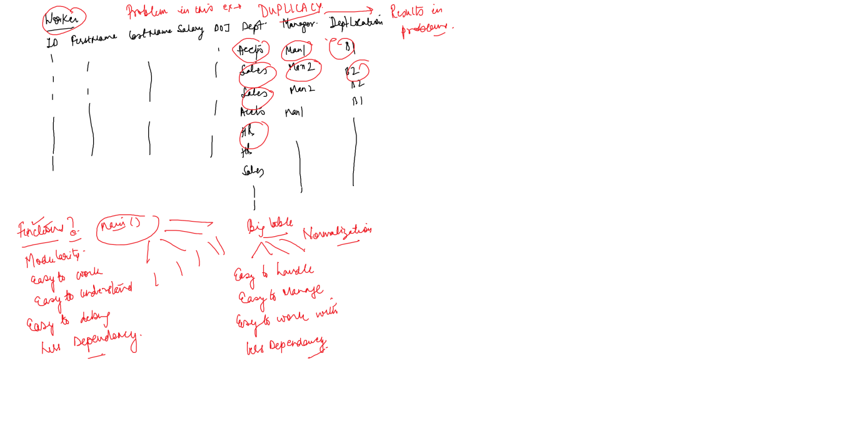

create table batch (id int primary key,

batchname varchar(20), course varchar(20))

insert into batch values(101, 'B001', 'C#'),

(102, 'B002', 'Java'),

(103, 'B003', 'VB'),

(104, 'B004', 'Database')

create table student(rn int primary key, name varchar(20),

bid int references batch(id))

insert into student values(1,'Ajay', 101)

insert into student values(2,'Deepak', null)

insert into student values(3,'Deepak', 103)

select \* from batch

select \* from student

-- Joins are used to bring data from more than 1 table

-- 1 Inner Join ( We need a common column) > Gives you matching records

-- 2 Outer Join ( We need a common column) > Gives you matching as well as non matching records

-- 1 Left outer join

-- 2 Right outer join

-- 3 Full outer join

-- 3 Cross Join ( We do not need a common column) It gives you product of two tables

-- 4 Self Join ( A table joins to itself)

-- Give me student name & their batch details

-- inner join

select name , batchname from student join batch

on bid=id

select student.name , batch.batchname from student join batch

on student.bid=batch.id

select a.name , b.batchname from student a join batch b

on a.bid=b.id

-- Give me all the batches & students enrolled

select a.name , b.batchname from student a right outer join batch b

on a.bid=b.id

-- Give me all the studnets & batch

select a.name , b.batchname from student a left outer join batch b

on a.bid=b.id

select a.name , b.batchname from student a full outer join batch b

on a.bid=b.id

-- All the students shoud be enrolled in all batches

select \* from student cross join batch

-- Self join

select \* from emp

alter table emp add managerid int

update emp set managerid=3 where id in (1,4,5)

update emp set managerid=6 where id in (2,3)

update emp set managerid=1 where id in (6)

-- Display employee name & their manager name

select a.name as "Employee Name" , b.name as "Manager Name" from emp a join emp b

on a.managerid = b.id